05. Heap

- Introduction

Priority queue is implemented by binary heap (or heap). It can be used by the applications that require priority, such as the job schedulers of a printer or an operating system.

A heap is a binary tree that is completely filled, with the possible exception of the bottom level, which is filled from left to right. Such a tree is known as a complete binary tree. A complete binary tree has the following attributions, where n is the number of nodes and h is the height of the tree.
- 2^{h} <= n <= 2^{h+1} – 1
- h = ⎣log n⎦

In a heap, for every node X, the key in the parent of X is smaller than the key in X. This means that the root is always the minimum element.

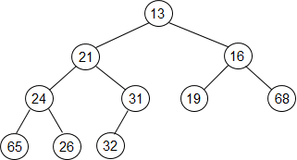

A heap can be implemented using an array. For any node in position i, its left child is in position 2i, its right child is in position 2i + 1, and its parent is in position ⎣i / 2⎦.

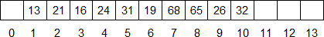

The data structure of a heap will consist of an array and an integer representing the current size of the heap.

- Heap Operations

The two basic operations of the priority queue are insert and deleteMin, which are equivalent of the enqueue and dequeue operations, respectively.

Insert

To insert a new element X into the heap, first we create a hole in the next available location. If X can be placed in the hold without violating heap order, then we do so and are done. Otherwise, we slide the element of the hole’s parent into the hole, thus bubbling the hole up toward the root. We continue this process until X can be placed in the hole. The time complexity is O(log n).

int hole = ++currentSize;

while (hole > 1 && x < array[hole / 2])
{
array[hole] = array[hole / 2];
hole /= 2;
}

array[hole] = x;

The following shows how to insert an element 18.

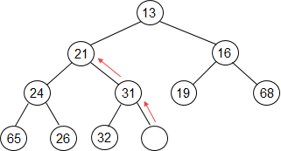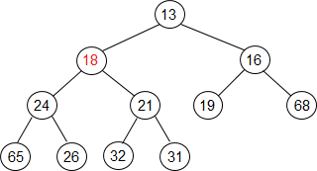

deleteMin

In a heap, the root is always the minimum element. The deleteMin operation needs to delete the root and yields a different heap. When the root is removed, a hole is created at the root. The last element in the heap must move somewhere in the heap because the heap now becomes one smaller. We slide the smaller of the hole’s children into the hole, thus pushing the hole down one level. We repeat this step until the last element can be placed in the hole. The time complexity is O(log n).

int lastValue = array[currentSize];
int hole = 1;

int child = hole * 2;
if (array[child] > array[child + 1])
++child;

while (child < currentSize && array[child] < lastValue)
{
array[hole] = array[child];
hole = child;

child = hole * 2;
if (array[child] > array[child + 1])
++child;
}

array[hole] = lastValue;
--currentSize;

The following shows how to delete the root 13.

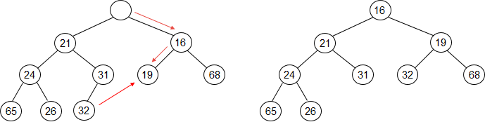

A heap is designed to find the minimum element in a collection. It is of no help in finding the maximum element.

- Application Example

In a list of n elements, find the k-th largest element.

Algorithm A

First construct an empty heap, and insert all the elements. Then we perform the deleteMin operations for k times. The last element removed from the heap is the k-th smallest element. If we perform the deleteMin operations for n – k times, the last element removed is the k-th largest element.

Algorithm B

Read the first k elements into an empty heap. For the other n - k elements, read them one by one. When a new element is read, it is compared with the root of the heap. If the new element is smaller, discard it. Otherwise, we replace the root with the new element and execute percolate down to select the smallest element in the heap. At the end of the input, the root will be the k-th largest element.

- d-Heap

A d-heap is a completed tree in which each node has exactly d children, except the node that is the parent of the last node. A d-heap is much shallower than a binary heap, improving the running time of the insert operation. However, the deleteMin operation is more expensive.

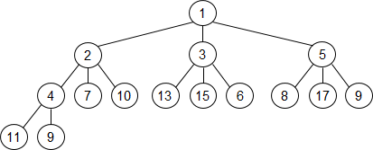

- Leftist Heap

The null path length of a node X is the length of the shortest path from X to a node without two children. It can be written as NPL(X). The NPL of a node with zero or one child is 0, while NPL(NULL) = -1. The null path length of any node is one more than the minimum of the null path length of its children. A leftist heap is a heap in which, for any node X, the null path length of the left child is at least as large as that of the right child.

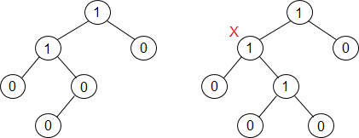

The following shows the data structure of the leftist heap. The npl field indicates the null path length of the node.

struct LeftistNode
{
int element;
LeftistNode *left;
LeftistNode *right;
int npl;
}

The fundamental operation on leftist heaps is merging. The time complexity of merging two leftist heaps is O(log n). The following shows the recursive solution.
- If either of the two heaps is empty, then return the other heap.
- Otherwise, we compare the roots of the two heaps. Suppose that H₁ is the heap with the smaller root and H₂ is the heap with the larger root. First, we recursively merge H₂ with the right sub-heap of H₁, and denote the new heap by H’. Then we make H’ as the right child of the root of H₁.
- If the NPF of the right child is greater than that of the left child, to satisfy the leftist property, we just swap the root’s left child and right child, and update the null path length of the root by NPL(right child) + 1.

The following shows two leftist heaps.

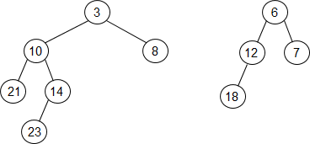

The following merges the right sub-heap of H₁ and H₂ recursively, makes H’ as the right child of the root of H₁, and then swaps the left child and right child of the root.

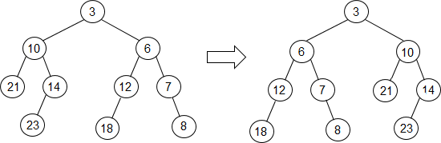

The insert operation is just a special case of the merge operation. You can just insert the new element into an empty heap and then perform the merge operation with the existed heap. To implement the deleteMin operation, you can remove the root and perform the merge operation on the left and right children.

- Skew Heap

A skew heap is a binary tree with heap order, but there is no structural constraint on it. The merge operation of a skew heap is almost the same as that of a leftist heap. For skew heap, instead of checking to see whether the left and right children satisfy the leftist order property and swap them if they do not, we always swap them after we make H’ as the right child of the root. The following shows the merging result for the previous example.

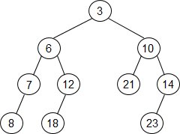

Skew heaps have the advantage that no extra space is required to maintain path lengths, and no tests are required to determine when to swap children. It is much simpler to implement.

- Binomial Queue

A binomial queue is a collection of binomial trees.
- There is at most one binomial tree of every height.
- A binomial tree of height 0 is a one-node tree.
- A binomial tree B_{k} of height k is formed by attached a binomial tree B_{k-1} to the root of another binomial tree B_{k-1}.
- A binomial tree B_{k} consists of a root with children B₀, B₁, …, B_{k-1}.

The following shows a binomial queue with four binomial trees.

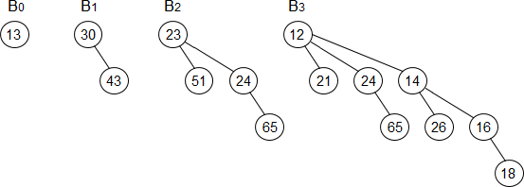

We can represent a priority queue of any size by a collection of binomial trees. For instance, a priority queue of size 13 could be represented by the binomial trees B₃, B₂, B₀. We can write this representation as 1101, which not only represents 13 in binary but also represents the fact that B₃, B₂, and B₀ are present in the representation and B₁ is not.

Binomial queue supports the merge, insert, and deleteMin operations in O(log n) worst-case time. The insert operation can take constant time on average.

Merge

Suppose that we want to merge two priority queues A = (A₁, A₂) and B = (B₀, B₁, B₂). The merging is performed by adding the two queues together. Let C be the new binomial queue.
- Since A has no binomial tree of height 0 and B does (B₀), we can just use B₀ as part of C.
- Next, we merge the binomial trees of height 1, A₁ in A and B₁ in B, by making the large root a subtree of the smaller, creating a binomial tree of height 2, C₂.
- We keep one of the binomial trees of height 2, A₂, B₂, C₂, in C, and merge the other two, creating a new binomial tree of height 3, C₃. So we have C = (B₀, A₂, C₃), (B₀, B₂, C₃), or (B₀, C₂, C₃).

The following shows two binomial queues.

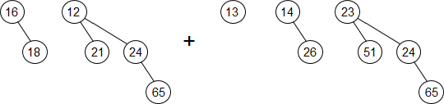

The following shows the merged result.

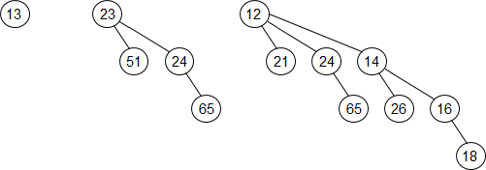

insert

The insert operation is a special case of merging, since you can merely create a one-node tree and perform a merge.

deleteMin

The following shows how to perform the deleteMin operation.
- First scan the roots of all the trees to find the binomial tree with the smallest root. Since there are at most (log n) trees, the scan can be done in O(log n) time. Alternatively, you can maintain knowledge of the minimum and perform the operation in O(1) time, if you update the minimum when it changes during other operations.
- Second, remove the root of the binomial tree with the smallest root. It generates two priority queues.
- Then merge the two priority queues and the rest binomial trees of the original priority queue.

The following shows the result after removing the element 12 in the previous priority queue.

